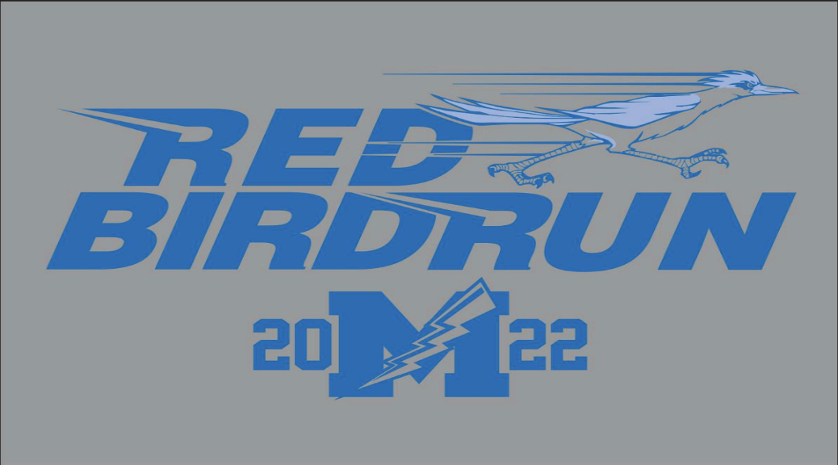
MAY 15th 2022 Kids Race at 9 AM – 5 K Run/Walk at 9:15
A fun Flat race on the shores of Lake Erie to benefit Madison Track & field
North Elementary School- 1941 Red Bird Road Madison Ohio 44057
* Checks made out to Madison Track * $20 Race day
-Male & Female Prizes for top 3 Overall + Age groups awards
(14 and under) (15 to 19) (20 to 29) (30 to 39)(40 to 49)(50 to 59) (60 +)

